SCI’s Response to information request
September 2013

Table of Contents

1.1. Break down of programme costs 1
1.1.2 Programme Expenses 3
1.1.3 MDA Costs 4
1.1.4 Unrestricted donations 4
1.1.4a Expenditure October 2012 – August 2013 4
1.1.4b Committed expenditure 6
1.1.4c Summary of Expenditure and commitments 8
1.2 Combining funds from other stakeholders 8
2.1 Overview of M&E 9
2.1.1 Prevalence Mapping to determine treatment strategy 11
2.1.3 Mean estimates of key variables across all schools 12
2.2 Plots of school-level prevalence for each parasite 13
2.3 Plots of school-level Intensity for each parasite 14
3.1 SCI Overview August 2013 15
4.1 Global Need 16

Requested information: More detailed and conceptual budget. We don't have very good resolution on what SCI spends money on in its projects (e.g., funds that go to SCI staff travel/meetings vs funds that pay for treatments vs. funds that pay for per diems for local health workers). We also don't know how this is combined with funds provided by other players, e.g., the local government or other NGOs. We would really value having this level of understanding of your activities.

1.1. Break down of programme costs
In order to give greater resolution on how SCI spends its funds we have provided a financial summary of the DFID funded project that currently delivers treatments to 8 countries. Data have been provided over 3 financial years. During this time period 12,198,157 treatments have been delivered.

This gives a direct financial cost per treatment of 40 pence. These figures are broadly representative of other implementation projects in SCI but do not include funds allocated to advocacy and fundraising.
Table 1: Summary of total DFID project expenditure versus actuals by 31st March 2013 (reporting period: 1st Oct 2010 – 31st March 2013)
Budget Line | Actual Expenditure | % of budget  Total | Budgeted Expenditure | % of actual total | Variance actual vs. budget
Management Personnel | £489,942 | 10.9 | £417,983 | 8.6 | -17%
Technical Personnel | £1,395,894 | 31.0 | £1,356,835 | 27.9 | -3%
Management Travel | £33,876 | 0.8 | £54,947 | 1.1 | 38%
Technical Travel | £187,039 | 4.2 | £223,361 | 4.6 | 16%
Technical reimbursable | £17,258 | 0.4 | £66,693 | 1.4 | 74%
Programme Expenses | £2,347,914 | 52.1 | £2,747,389 | 56.4 | 15%
Partner VAT charge | £30,524 | 0.7 | £0 | 0 | -
Total | £4,502,448 | 100 | £4,867,208 | 100.0 | 7%
Table 1 outlines all project expenditure to date against the original approved budget and by line items as invoiced to DFID. FY1 (Oct 2010-March 2011) was the project inception period as contracted by DFID, representing 5% of the total expenditure to date. FY2 (April 2011-March 2012) was essentially the initial set-up phase on the project cycle with full project implementation in all 8 countries achieved by FY3 (April 2012 – March 2013), with country programmes accounting for 58.0% of annual project spend in FY3.
Table 2: Budget Line Item narrative
Line item | Description
Management Personnel | Professional Fees: UK-based SCI and LSTM* personnel undertaking project operational and financial management; project administration.
Technical Personnel | Professional Fees: UK-based Technical Director, country programme managers, health economist, biostatistician, data manager; Ugandan-based capacity building advisor.  Technical Assistance: Consultancy fees for expertise outwith project staff.
Management Travel | National and International travel (air, land and sea) with associated subsistence (including visa and necessary health precautions) for planning, implementation and partnership meetings.
Technical Travel | National and International travel (air, land and sea) with associated subsistence (including visa and necessary health precautions) for technical, planning, implementation, training, monitoring and evaluation meetings.
Technical reimbursable | Communications; legal fees; financial charges and fees (including audits); DFID evaluations
Programme Expenses | Country Programmes: All costs incurred at country level including (but not limited to) mapping of priority disease risk areas; cascaded training of educators and health workers in treatment delivery; drug clearance, storage and transportation; drug delivery in schools, high-risk communities; supervision of implementers; medical supervision in case of adverse events; programme monitoring and evaluation.
Partner VAT charge | VAT payable to subcontractors LSTM and LATH
*LSTM – Liverpool School of Tropical Medicine partners
LATH – Liverpool Associates in Tropical Heath

1.1.2 Programme Expenses
Since programme expenses account for over 50% of the project budget we have provided a further breakdown of how these funds are allocated in endemic countries. We have used Malawi as an example.
Table 3: Agreed budget for 2012 for Malawi to demonstrate the breakdown of activities supported by DFID
ACTIVITY | TOTAL (local currency) | TOTAL (GBP) | percentage
STAKEHOLDERS MEETING AT CENTRAL LEVEL | 1,858,000 | £6,967.50 | 1.85%
SOCIAL MOBILISATION | 5,698,000 | £21,367.50 | 5.66%
TRAINING OF TRAINERS | 2,151,000 | £8,066.25 | 2.14%
TRAINING OF SUPERVISORS
TRAINING OF TEACHERS/HSAS | 9,646,600 | £36,174.75 | 9.60%
PRODUCTION OF TREATMENT REGISTERS | 2,000,250 | £7,500.94 | 1.99%
PRODUCTION OF TRAINING MANUALS | 1,003,500 | £3,763.13 | 0.99%
PRODUCTION OF DOSE POLES | 1,000,000 | £3,750.00 | 0.99%
PRODUCTION OF IEC MATERIAL | 501,200 | £1,879.50 | 0.50%
DRUG STORAGE & SECURITY
DRUG TRANSPORT | 6,386,667 | £23,950.00 | 6.35%
MDA COSTS | 23,442,000 | £87,907.50 | 23.30%
SUPERVISION | 10,556,000 | £39,585.00 | 19.50%
POST-MDA DISTRICT EVALUATION MEETING
POST-MDA NATIONAL & REGIONAL EVALUATION MEETING | 4,451,600 | £16,693.50 | 4.42%
M&E: SENTINEL SITES (2013) | 14,036,200 | £52,635.75 | 13.96%
M&E: KAP SURVEY | 4,484,000 | £16,815.00 | 4.29%
SCHISTO/STH DISEASE MAPPING |  | £0.00
DISTRICT VISIT FOR NGO INVENTORY
DISTRIBUTION OF PZQ SYRUP
TRAINING OF DISTRICT STAFF ON DIAGNOSIS
PROGRAM OFFICE SUPPORT | 5,746,952 | £21,551.07 | 5.71%
COVERAGE VALIDATION SURVEYS | 7,260,000 | £27,225.00 | 7.22%
M&E: SENTINEL SITES (2012) SUPERVISION AND DATA ENTRY | 285,000 | £1,068.75 | 0.28%
THE COMPLETION OF MAPPING ACTIVITY
CLEARANCE COSTS (VEHICLE)
TOTAL | 100,506,969 | £376,901.13

1.1.3 MDA Costs
Within programme expenses MDA costs account for about a quarter of the total expenses. We have therefore provided a further breakdown of this category. We have shown the percentage of funds allocated to each of the activities in two countries as an illustration.
Table 4: Cost categories for the implementation of MDA
Activity | % Distribution by cost
 | Cote d’Ivoire | Liberia
Drug logistics | 5% | -
Supervision & support | 4% | 14%
Social Mobilisation | 9% | 11%
PCT delivery | 23% | 24%
Training | 59% | 51%
Total | 100% | 100%

We would appreciate if it these figures were not published or circulated until we have approval from DFID.

1.1.4 Unrestricted donations

1.1.4a Expenditure October 2012 – August 2013

Total unrestricted funds received for 1 October 2012 to 31 August 2013 was £1,502,336.20
These unrestricted funding were primarily from small donation less than £1000 with the exception of a few large donations of which Good Ventures ($250,000) was the largest.
Total unrestricted funds spent (not including commitments):
The above tables are taken from data from the countries supported by DFID. In country programmes supported by other donations have similar cost breakdown. However to illustrate further the expenditure from other donations the table below show the percentages for different cost categories from 1 Oct 2012 – 31 August 2013.
Table 5: Expenditure by category of private donations 1 October 2012 – 31 August 2013
Table 5 demonstrates that commitments made at previous resource allocation meeting for example October 2012 for mapping in Zimbabwe and mapping and treatment in Ethiopia have been fulfilled.
Private donations 1 Oct 12 – 31 Aug 13
SCI expenditure category | Sum in GBP
 | Total expenditure | % of total
Advocacy & Fundraising - Travel | 2,482 | 0.2
Advocacy & Fundraising - Salary | 18,693 | 1.8
Advocacy & Fundraising - Resources | 15,532 | 1.5
SCI Development - Salary | 25,104 | 2.4
SCI Development - Travel | 28,782 | 2.7
SCI Development Training | 1,003 | 0.1
SCI Development - Office Running Support | 4,789 | 0.5
SCI Development - Strategic Partnership | 6,321 | 0.6
SCI - Students Support | 1,413 | 0.1
Enhanced monitoring and evaluation | 14,517 | 1.4
Country Programmes*
Cote D'Ivoire | 30,000 | 2.8
DRC | 7,239 | 0.7
Ethiopia | 596,044 | 56.3
Liberia | 5,182 | 0.5
Madagascar | 1,314 | 0.1
Mauritania | 39,589 | 3.7
Mozambique | 20,925 | 2.0
Rwanda | 1,314 | 0.1
Senegal | 90,239 | 8.5
Uganda | 1,424 | 0.1
Yemen | 37,279 | 3.5
Zimbabwe | 110,000 | 10.4
Total Country Programmes | 940,549 | 88.8
Total Expenditure | 1,059,185 | 100.0
*breakdown of programme expenses are broadly similar to those illustrated in Table 3 in most cases

Table 6. Budget line item narrative for Table 5.
Line item | Description
Advocacy & Fundraising travel, salary and resources | Salary support and travel for part time Donor relationship manager. Development and production of promotional material.
SCI Salary Support | Support for SCI staff working on investigating the possibilities of new country programmes and supporting established programmes as needed. Longer term support for staff is usually allocated to larger awards however having a flexible funding mechanism is essential to maintain experienced staff.
SCI Development Travel | To support SCI staff members travelling to countries where programmes have not yet been established but there is interest in starting an NTD programme. Costs include travel to attend meeting with Ministries of Health and other stakeholders. and for conferences and meetings to disseminate information.
SCI Development – Training | SCI supports technical training of SCI team and capacity building through work with SCI’s African Capacity building manager based in Uganda. Training includes activities such as field training of technicians in diagnostic techniques.
SCI Development – Office Running cost | To support office running costs
SCI Development Strategic Partnerships | Supports cost for memberships of relevant stakeholder groups e.g. The UK Coalition against NTDS and support of the All Party Parliamentary Group on Malaria and NTDs
Enhanced Monitoring and Evaluation | Supports work that conducts additional monitoring and evaluation of programmes to answer specific operational questions that assist in the validation and development of international guidelines
Student Support | SCI will give some financial assistance to students to carry out specific pieces of work that are required to support SCI programmes. Students are selected through a competitive process on most occasions and will make significant financial contributions to their trips. Often pieces of work will be part of an Imperial College degree course.

1.1.4b Committed expenditure

SCI convenes 6 monthly resource allocation committee meetings. The committee will discuss up-coming projects and assess funding proposals made by internal and external collaborators. Commitments are made in line with the SCI strategic plan and the SCI research agenda.

Table 7 . Commitments made at August 2013 Resource allocation meeting
Recipient | SCI Expenditure category | GBP  (£) | Comments | Date committed | Timeline of Expenditure
University of Queensland | Enhanced Monitoring and Evaluation | £9,375 | PhD student support for development of decision making tools for NTD programme managers | Mar 13 | Oct-13
University of Cambridge | Enhanced Monitoring and Evaluation | £70,000 | Collaboration with University of Cambridge assessing strategies to increase coverage | Mar 13 | Sep-13
Ethiopian Ministry of Health | Ethiopia | £222,500 | To support mapping and treatment of at risk regions | Aug 13 | Dec-13
Senegal Ministry of Health | Senegal | £160,000 | Support of M&E of USAID funded SCH treatment at request of MOH | Aug 13 | Jan 14 – Jan 18
Ugandan Ministry of Health | Enhanced Monitoring and Evaluation | £20,000 | Enhanced M&E in Uganda to explore elimination strategies | Aug 13 | Dec-13
Technical University Munich | Enhanced Monitoring and Evaluation | £20,000 | Matched funding with BMGF to support cysticercosis project in Malawi | Aug 13 | Dec 14
Donor Relationships manager | SCI development | £10,000 | Funds to support improved donor communication or resources | Aug 13 | June 14
University of Antwerp | Capacity building | £45,000 | Analysis of the best approaches to capacity building in Burundi | Sep 13 | Sep-13
DRC Ministry of Health | DRC | £60,000 | In partnership with CNTD, Liverpool support coordinated mapping in at risk | Aug 13 | Aug-14
Mozambique Ministry of Health | Mozambique | £400,000 | To support treatment of at risk populations | Aug 13 | Mar 14
University of Edinburgh | Zimbabwe | £140,000 | In partnership with University of Edinburgh to support mapping and treatment of at risk regions | Sep 13 | June 14
SCI team | SCI Development Travel | £20,000 | SCI team travel | Sep 13 | Oct 2014
TOTAL COMMITTED FUNDS |  | £1,176,875

1.1.4c Summary of Expenditure and commitments

Opening Balance of unrestricted funds at 1 Oct 2012 | 1,255,416.97
Add: Unrestricted Income during Oct 2012 - Aug 2013 (section 1.1.4a ) | 1,502,336.20
Less: Total Expenditure (Oct 2012 - Aug 2013) | (1,059,185.00)
Available unrestricted funding at 31 Aug 2013 | 1,698,568.17
Less: Committed costs (as shown in Table 7) | (1,176,875.00)
Available uncommitted funds at 31 Aug 2013 | 521,693.17

1.2 Combining funds from other stakeholders
The British and American governments are still the major bilateral donors that support implementation of preventative chemotherapy (PCT) against schistosomiasis. USAID provides funds through a contracting organisation (RTI) who in turn engage NGOs and other agencies to implement programmes in endemic countries while DFID work directly with implementing NGOs. It is crucial for all key stakeholders to work collaboratively with Ministries of Health to ensure that the available resources are used most effectively. In order to facilitate this collaboration annual stakeholders meetings are held hosted by endemic country Ministries of Health. At these meetings comprehensive work plans are developed and costed in line with National Strategic Plans for NTDs and stakeholder funds allocated. This encourages transparency and coordination of approaches.
In order to give a more detail of the breakdown of cost we refer you to a paper written by Dr Jackie Leslie who previously worked at SCI as our health economist. http://www.plosntds.org/article/info%3Adoi%2F10.1371%2Fjournal.pntd.0001326
This shows the full economic costs and the approbation of funds between partners in Niger. In brief 75% of the costs were attributable to programme costs including drug cost. These costs would typically be supported by external partners e.g. iNGDOs and in the case of Niger an SCI programme supported by USAID. The government contribution was 18% which would include in kind support and international technical support (again in this instance SCI) made up about 7% of the full economic cost of the national SCH and STH mass drug administration. See table 7.
In addition we are working with Research Triangle International the contractors for the USAID NTD programme and WHO on a costing tool that is designed to capture the contributions to different stakeholders to programmes identifying funding gaps and to assist with on-going financial planning. The tool is currently being rolled out and we are not yet in a position to share this but would be very happy to do so when the data becomes available.

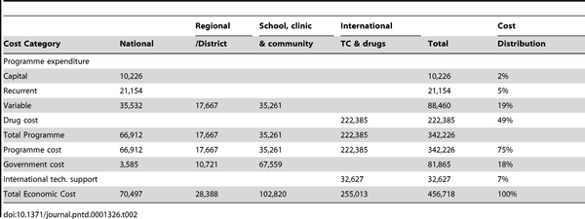
Table 8. Discounted economic cost of the MDA programme for April 2004 to March 2006 in 4 districts (2005 prices).
Requested Information: Ongoing, technical M&E reports. On our SCI review page, we discuss technical M&E reports, but these date back to 2010. We're hoping for more up-to-date monitoring reports on countries you've worked in since then. In particular, the Burundi report we discuss on our SCI review page is a good example of the type of report we'd be looking for.

2.1 Overview of M&E
As Givewell is aware SCI has implementation projects at different stages of development. Figure 1 below broadly illustrates the stage of each country. The WHO strategic category is also indicated (see table 3). The majority of SCI assisted countries are still targeting control of morbidity while only Uganda, Niger, Zanzibar, Rwanda and Burundi are in a position to move into exploring the elimination phase. The treatment strategies to achieve elimination have not been fully elucidated and SCI are working closely with WHO to define and validate guidelines in these area. Therefore the monitoring and evaluation protocols in these countries are very context specific.

Niger
Uganda
Zanzibar
Malawi
Mozam-bique
Yemen Rwanda
Burundi

Liberia
Zambia
Tanzania
Mauritania
Senegal

Cote d’Ivoire
Ethiopia
DRC
WHO Category: Control of morbidity
WHO Category: Interruption of transmission
WHO Category: Elimination as a public Health problem

Figure 1: Illustration of stages of development of SCI assisted countries
Control of Morbidity | Elimination as a public health problem | Interruption of transmission
Strategy : 100% geographical and 75% national coverage with PCT | Adjusted PCT and complementary interventions recommended | Intensified PCT and complementary interventions essential
Target: Prevalence of heavy intensity infection <5%* | Prevalence of heavy intensity infection <1%* | Reduction of incidence of infection to zero
Timeline: Up to 5-10 years from joining the group | Up to 3-6 years from joining the group | Up to 5 years from joining the group
* In sentinel sites
Figure 2: Suggested target and timelines for Schistosomiasis Elimination Source : Schistosomiasis: progress report 2001-2011 and strategic plan 2012-2020, World Health Organization ISBN 978 92 4 150317 4

In order to demonstrate in more detail an on-going monitoring and evaluation process within a designated country supported by SCI we have taken the example of Liberia (see below).
We have also included a recent report from Ethiopia which has been supported primarily through small donations to date. See ANNEX A.

2.1.1 Prevalence Mapping to determine treatment strategy
A statistically representative number of schools are selected for mapping. Samples are collected from school aged children and disease prevalence is calculated. The exercise is appropriately powered to allow implementation areas to be categorised as high, medium, or low prevalence. WHO guidelines provide direction on the appropriate treatment strategies for each of the categories.
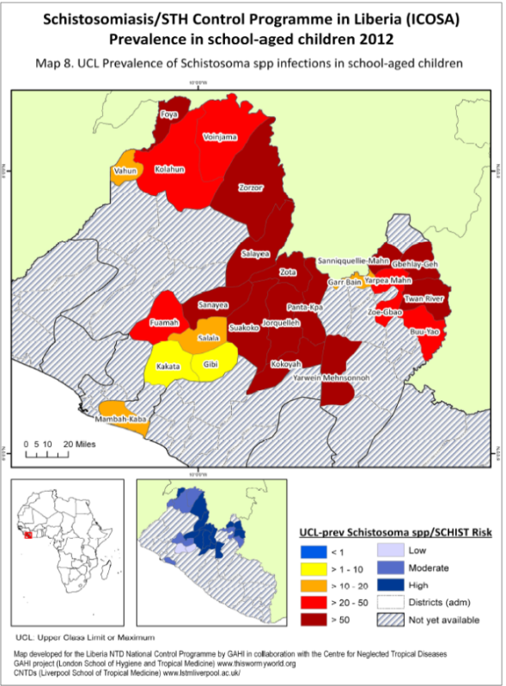
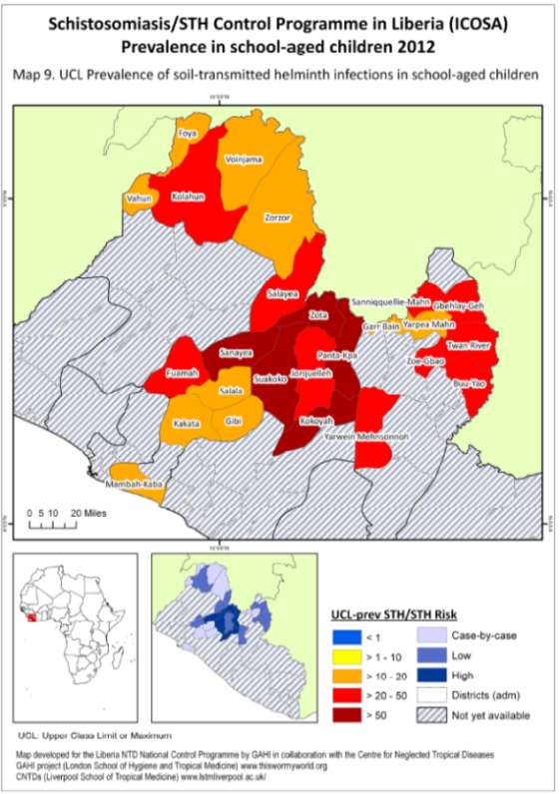

Figure 2: Shows prevalence maps for a) Schistosomiasis and b) Soil transmitted helminths in selected implementation areas in Liberia. Data collected in 2012.

2.1.3 Mean estimates of key variables across all schools
Prior to administration of PCT baseline data is collected from a selected number of schools known as sentinel sites. The number of schools sampled is calculated in order to demonstrate the impact of treatment over the whole of the programme area.
There is always a trade off in terms of collecting large amounts of data allowing for more detailed analysis versus the cost. This is particularly relevant in situations where the treatment costs are low and the safety profiles are favourable. WHO suggest that 10% of programme costs should be allocated for monitoring and evaluation. Both the prevalence (an indicator of the presence of the disease in groups of individuals) and the intensity (the number of eggs per person) of infection are collected as baseline data. Changes in intensity following treatment are thought to give a more accurate measure of impact and can also be used as a surrogate for morbidity.
Mean Prevalence and Intensity data for SCI programme area in Liberia 2012
Sh prev | prev Sh heavy | Sh intensity | Sm prev | prev Sm heavy | Sm intensity | Ascaris prev | Trichuris prev | Hookworm prev
19.4% | 9.0% | 42.36 | 26.2% | 0.2% | 16.32 | 27.8% | 0.7% | 15.2%
Table 2.1: Mean prevalence of any infection (prev), prevalence of heavy infection (prev heavy) and intensity (intensity, measured as eggs per 10ml of urine and/or eggs per gram of faeces) across programme area in Liberia for infections with Schistosoma haematobium (Sh), Schistosoma mansoni (Sm), and the Soil transmitted helminths (Ascaris, Trichuris and Hookworm).

2.2 Plots of school-level prevalence for each parasite
Prevalence per school is calculated and data collated to give a mean prevalence per implementation area (usually a district but context specific). The plots below illustrate the prevalence of Ascaris, hookworm, S. haematobium and S. mansoni in different schools in the 3 implementation areas within Liberia

2.3 Plots of school-level Intensity for each parasite
The below plots show the arithmetic mean intensity of infection per school, measured as eggs per gram of stool for S. mansoni and the soil-transmitted helminths. Error bars are 95% negative binomial confidence intervals. Data for S. haematobium infection are currently being analysed.

S. haematobium data aree still being analysed.

Prior to each round of PCT further samples will be collected from sentinel site schools and prevalence and intensity of infection is calculated. The mean reductions in prevalence and intensity can then be demonstrated. This is becoming increasingly important since the WHO is in the process of introducing new targets for treatment programmes which will be stated in terms of reduction in the prevalence of high intensity infections.
Please see attached at ANNEX B the detailed protocol for the Monitoring and Evaluation in Liberia.

3.1 SCI Overview August 2013
The SCI is currently providing support to fifteen countries in sub-Saharan Africa and the middle-east (Figure 1). This includes the planning, implementation, and monitoring of NTD control programmes, as well as the implementation of operational research. The SCI’s work is funded by major grants from DfID, Children’s Investment Fund Foundation, Bill and Melinda Gates Foundation, The End FUND, and by many private donors (both large and small). It seems highly likely that DfID will extend SCI’s current grant to support SCH/STH control in sub-Saharan Africa.
2013 has seen an increase in staff numbers within SCI. Wendy Harrison (Managing Director) returned to work in July following maternity leave. There have been the appointments of three new programme managers francophone (Sarah Ngoro) and anglophone (Jane Whitton, Yolisa Nalule), and a Senior M&E Manager (Fiona Fleming – currently on maternity leave). In addition a new researcher has been recruited to work on an operational research grant exploring mapping and modelling of schistosomiasis elimination (Arminder Deol). A Health Economist post is about to be advertised.
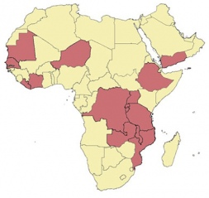
Figure 1. Countries with control programmes currently supported by SCI (or due to start in 2013)
- West Africa: Cote d’Ivoire, Liberia, Mauritania, Niger, Senegal
- Central Africa: DRC
- East Africa: Burundi, Ethiopia, Malawi, Mozambique, Rwanda, Tanzania (including Zanzibar), Uganda, Zambia
- Middle-east: Yemen
The SCI is now beginning to expand its scope to explore integrated/collaborative approaches to controlling disease. This includes a focus on water, sanitation and hygiene interventions and also with shoe donation programmes. It is hoped that the distribution of free shoes (from TOMS Shoes) will help to prevent schistosomiasis, STH (particularly hookworm), and podoconiosis infection. It will also help to provide an incentive for individuals to attend treatment.

4.1 Global Need

At a recent WHO meeting in July 2013 an expert committee, on which SCI was represented, looked at the global need for PZQ for the treatment of schistosomiasis. The table below shows the estimated population at risk of schistosomiasis which would require preventative chemotherapy. Additionally, Merck Serono has increased its donation of PZQ which should reach 250 million tablets annually by 2016. The donations are to be administered through WHO. Even with the increased donation of PZQ the need is significantly greater than the supply and the table below illustrates the allocation of donated drugs for 2013. It is obvious that many countries with a high burden of schistosomiasis still do not receive enough drug to treat their at risk populations.
Table 8: Global Need – estimated at risk populations in SCI assisted countries and WHO forecast for PZQ donations in number of tablets and doses (calculated as 2.5 tablets per dose). These figures have not yet been officially published. (The donations are from WHO and/or USAID – or from SCI (in red)
 | Burundi | Cote D'Ivoire | DRC | Ethiopia | Liberia | Malawi | Mauritania | Mozambique | Niger | Rwanda | Senegal | Tanzania  (Zanzibar) | Uganda | Zambia | Zimbabwe
At risk population WHO estimates 2012 (x1000) | 0.907m | 3.879m | 18.026m | 22.092m | 1.040m | 6.782m | 0.662m | 13.456m | 5.733m | 0.757m | 4.179m | 10.135m | 8.624m | 4.626m | 3.059m
2013 tablets  delivered  (SCI in red) | 0 | 3.83m | 1m | 3.5m | 2.7m | 16.5m | 0 | 0 | 15.7m | 0 | 4.149m | 8.0m | 6.0m | 5.125m | 3.519m
2013 doses  2.5 /dose | 0 | 1.53m | 400,000 | 1.4m | 1.08m | 6.6m | 0 | 0 | 6.28m | 0 | 1.66m | 3.2m | 1.5m | 2.05m | 1.41m

SCI is currently compiling its treatment figures and will be able to publish the percentage of this need that SCI has assisted endemic countries to cover in the next few weeks. WHO also complies treatment figures from Ministries of Health, which should give an estimate of the outstanding populations needing to be covered. Historically however, these figures are published about 24 months after treatment has taken place and often their accuracy is questioned.

