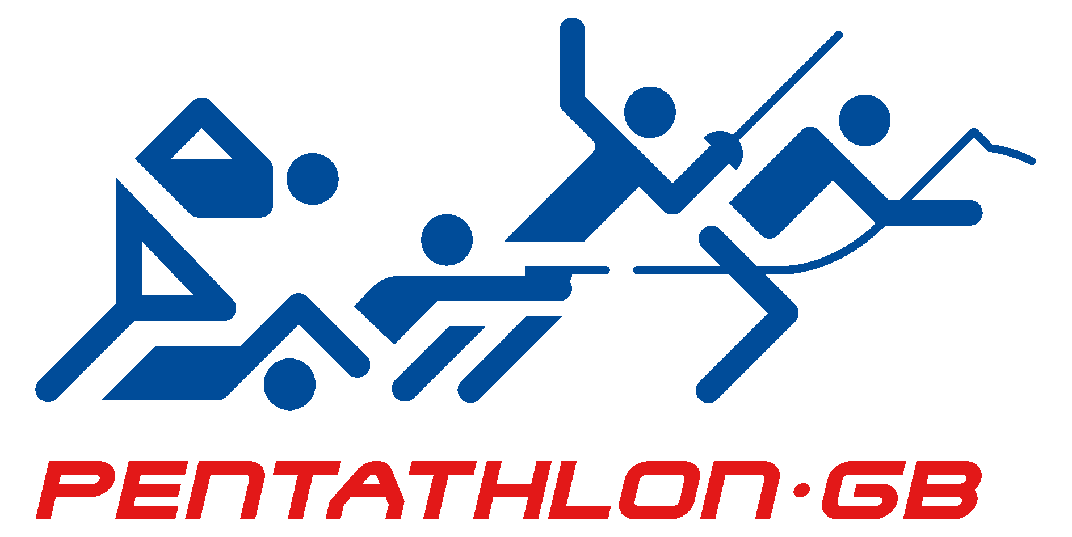

4th April 2014

GB YOUTH TEAM SELECTIONS

2014 SANT BOI INTERNATIONAL

BARCELONA 25TH – 27TH APRIL 2014

Girls:
Naomi Craig
Dani Chattenton
Charlotte Summers

Hannah Featherstone
Paris Allen
Kerenza Bryson

Boys:
William Eccleston
Henry Choong
Ben Pond

Harrison Yarnold
Josh Miller
Bradley Sutton

2014 WORLD YOUTH A CHAMPIONSHIPS

BUDAPEST – 14TH – 18TH MAY 2014

Girls:
Francesca Summers
Kerenza Bryson
Dani Chattenton

Eilidh Prise pre selected in accordance with PGB 2014 Selection Policy

Boys:
William Eccleston
Josh Miller
Henry Choong

2014 EUROPEAN YOUTH B CHAMPIONSHIPS

BARCELONA 30TH JULY – 4TH AUGUST 2014

Girls:

Hannah Featherstone
Paris Allen
Georgia Hannam
Zoe Gowers

Reserve athlete is Kerenza Bryson

Boys:

Myles Pillage
Harrison Yarnold
Josh Miller
Kelton Aldridge

Reserve athlete is Bradley Sutton

