Chris Watts Race Officials’ Education Officer, 02380 604157 chris.watts@rya.org.uk
Gordon Stredwick Racing Rules Manager, 02380 604171 gordon.stredwick@rya.org.uk
Jacqui Roberts Race Officials’ Administrator, 02380 604161 jacqui.roberts@rya.org.uk

RACE MANAGEMENT CO-ORDINATORS REGIONAL RULES ADVISERS

Robin Gray Northern Ireland Denis Todd
02891 459845 02890 428300
robin@robingray.co.uk d.o.todd@qub.ac.uk

Mike Butterfield North Wales Mike Butterfield
01248 810300 01248 810300
pmbutterfield@msn.com pmbutterfield@msn.com

David Kent Scotland Terence Brownrigg
01475 568833 01436 674151
Davidssi@btconnect.com terencebrownrigg@btopenworld.com

Robert Lamb Southern Martin Smethers
07850 714142 01425 652196
Robert.lamb@rscs.org.uk Martin@Smethers.co.uk

Richard Kingsnorth South East David Battye
01622 891653 01892 862347
richard@zwailing.co.uk davidmbattye@gmail.com

David Shepherd South Wales Eddie Ramsden
01446 774237 01792 420135
dwshepherd88@hotmail.com e.ramsden@rya-online.net

Mike Pearson South West Martin Smethers
01752 401949 01425 652196
mikebaylys@tiscali.co.uk Martin@Smethers.co.uk

Charles Wand-Tetley Thames Valley Chris Simon
01784 455084 01753 862194 crwt77@hotmail.com chrisimon@compuserve.com
Edwin Buckley East Trevor Lewis
01621 783480 01603 621126
edwin@edwinbuckley.co.uk tl@tlfs.org.uk
Northern Team
(North West, North East, Yorkshire & Humberside) Adrian Stoggall Peter Johnson
01625 871579 07545593341
stoggall@zetnet.co.uk mq22@liverpool.ac.uk
Henry Wright Carol Haines
01606 45137 01706 876623
wrightwally@aol.com chaines@tinyworld.co.uk
Eddie Ramsden
01792 420135
e.ramsden@rya-online.net
Midlands Team
(East & West Midlands)
David Wilkins William Jeffcoate
07768 300444 07900 551823
wilkinsd@cosmic-solutions.co.uk william.jeffcoate@tiscali.co.uk
David Hopkins Nadina Lincoln
02476 327971 01623 882909
david.hopkins5@sky.com nadina.lincoln@tiscali.co.uk
Chris Hadden
01332 519277
Chris.hadden@dsl.pipex.com


RACE OFFICIALS

Supporting the racing in our clubs

Free courses that the RYA can assist with at your club:

- Training for your race officers
- Improving the rules knowledge of your sailors
- Training Rules Advisers to resolve rules disputes
- Training mark layers in the latest methods
- Learn to get the best out of your GPS
- The latest advice on safety at large dinghy events

Contact your regional coordinator for assistance in arranging a course at your club

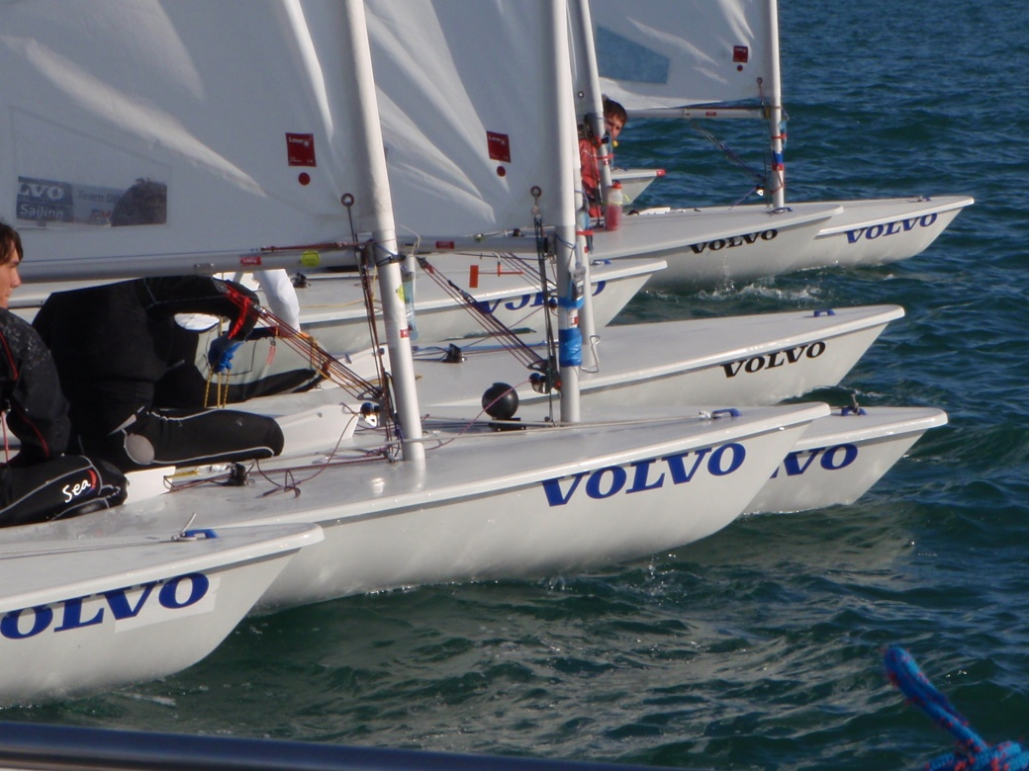
RYA WEBSITE www.rya.org.uk/raceofficials

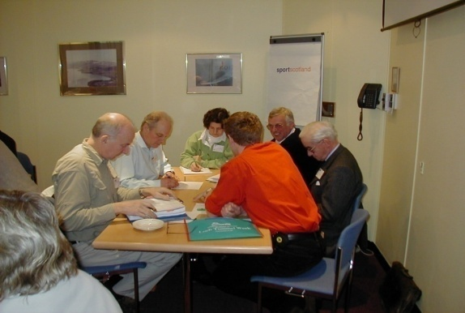
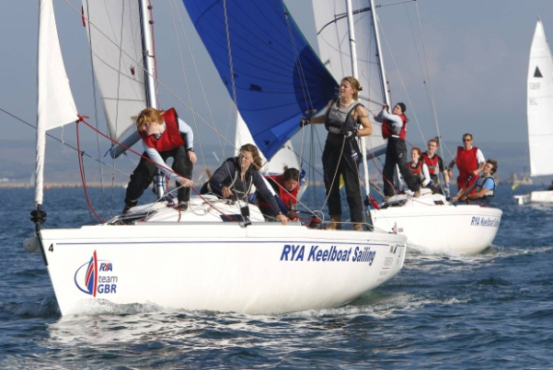
Club Race Officer
One of our long standing day courses arranged to support clubs in having a group of competent officials and based on how your club runs its racing.

Going by the Rules Sessions
The CD “Going by the Rules.” It can be delivered as a one day course or divided into several one hour sessions, to give sessions on the rules you need to - start, go up the beat or to go round marks etc. Contains a section on the changes in the rules for 2009.

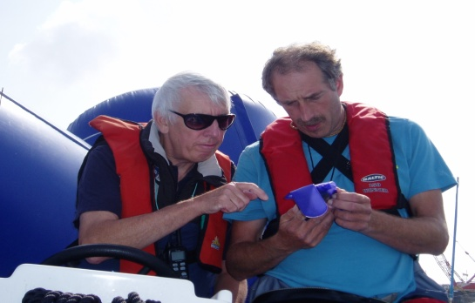
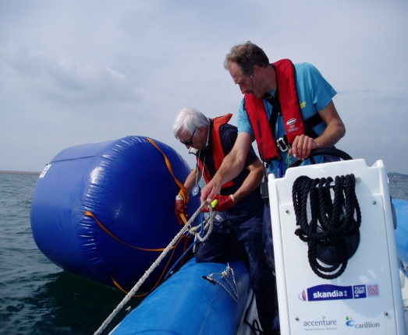
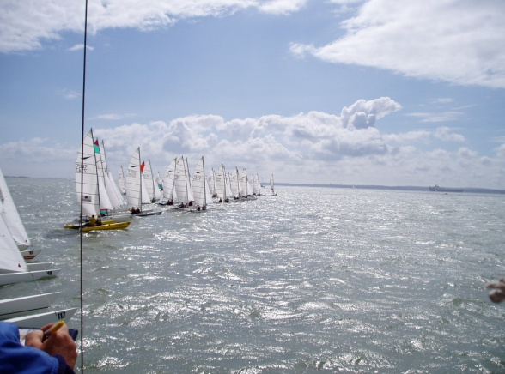
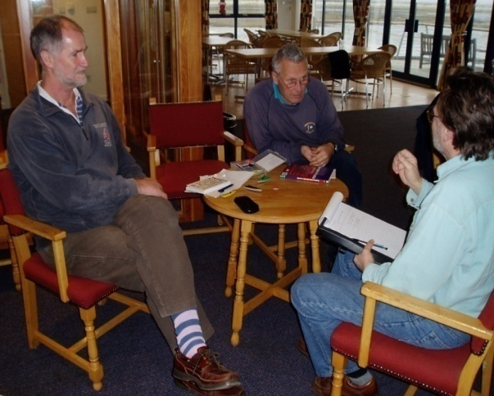
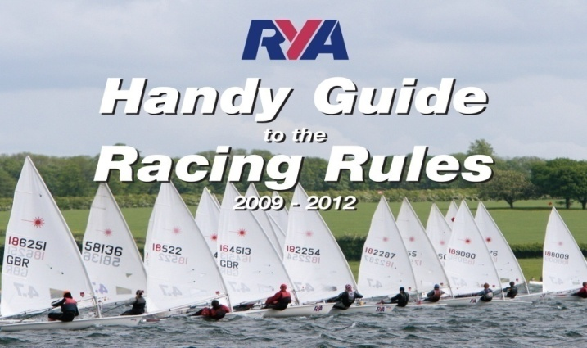
Basic Rules Courses
A very popular two hour course based on the Handy Guide and linked to many situations in club racing.

Club Rules Adviser
Every club should have one! Resolving racing disputes without all the aggravation of a protest hearing. This is the RYA dispute resolution process for club racing - part of the RYA Racing Charter drive to improve rules observance. A very interactive day course.

Club Mark Layer
A half day course designed to raise the standard and skill level of the club volunteers. A practical course with time on the water getting it right!
Dinghy Event Safety Planning
Just coming off the production line and being launched this year, this day course will be aimed at providing training and support for all those clubs running larger events. This will be organised on a regional basis with clubs invited to attend.
Using your GPS unit
Another half day course designed to teach the necessary skills to be a good mark layer.

- Race Management
- Judging
- Team Race Umpiring
- Match Race Umpiring
- Mark Laying
- International Seminars
www.rya.org.uk/raceofficials

Seminars run by the RYA to train and assist RYA Members to qualify as a Race Official.
www.rya.org.uk/raceofficials

