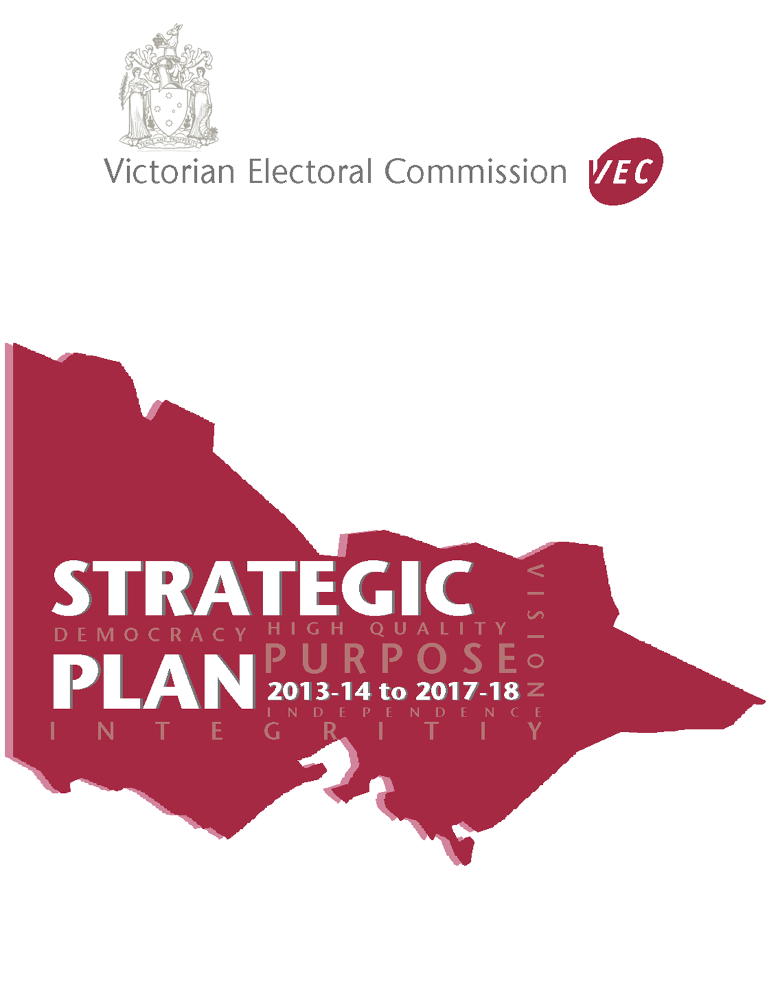

This document is effective as of 1 July 2016, inclusive of revisions, as authorised by W. Gately, AM, Electoral Commissioner, 530 Collins Street, Melbourne, Victoria.
Contents

Timeline of major events for the planning period 1
Introduction 2
Our Vision 3
Our Purpose 3
Our Strategic Intents 3
First Strategic Intent 4
Second Strategic Intent 6
Third Strategic Intent 8

Timeline of major events for the planning period

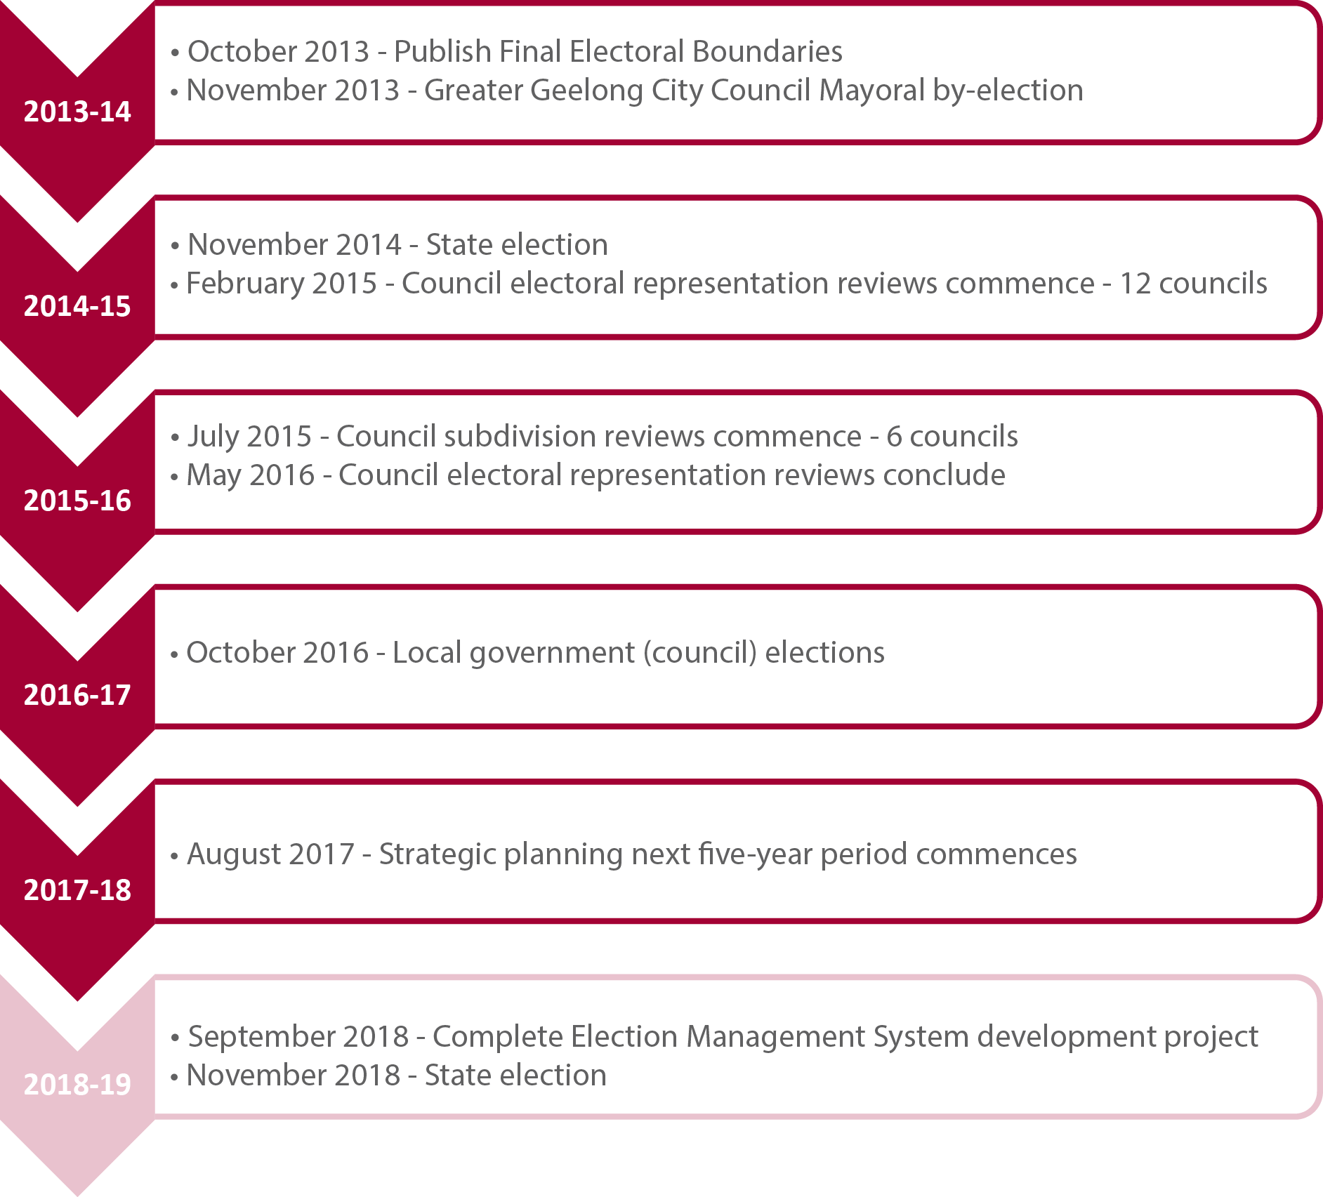

These are the principal, scheduled events in which the VEC will be engaged over the next five years. The many tasks and activities that comprise each event, are not identified, nor are those tasks that would be considered ‘business as usual’.
The VEC will report its achievements against this Strategic Plan in its annual reports. The Strategic Plan will be reviewed regularly to ensure it remains relevant to the VEC’s purpose and continues to support its strategic intent.

Introduction

The VEC operates within a complex, dynamic and challenging environment. State electoral law requires strict compliance, discipline and accuracy. The community requires integrity, transparency, high service delivery standards and innovation. Resource efficiency is demanded at all times.
In responding, the VEC requires clear direction and a strong planning framework to ensure robust long and short term plans. This Strategic Plan provides that direction. It outlines our future development initiatives, and identifies how the VEC will meet its continuing day-to-day statutory responsibilities. Priorities for the allocation of resources and effort will be clear allowing VEC staff to work effectively and with purpose.
A strong planning framework, underpinned by appropriate business support systems and a skilled and committed workforce, provides the VEC with capacity to meet immediate and changing business and electoral requirements.
Whether raising awareness of electoral matters, engaging Victorians in the democratic process, conducting Parliamentary and local government elections or polls, working collaboratively with other agencies, advisory groups, researchers and academics, the VEC is committed to having all Victorians participating in their democracy. This Strategic Plan and its supporting initiatives will move the VEC towards this vision.
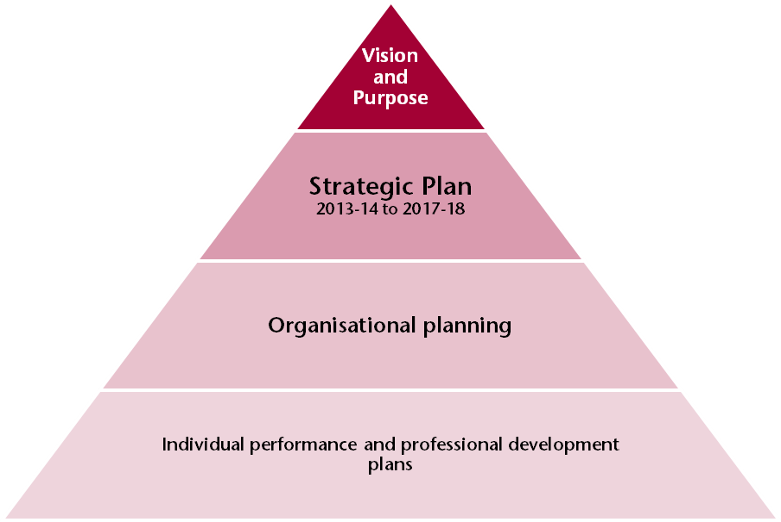

Our Vision
All Victorians actively participating in their democracy

Our Purpose
To deliver high quality, accessible electoral services with innovation, integrity and independence

Our Strategic Intents
- The VEC will provide high quality and innovative opportunities for all Victorians to participate in the democratic process
- The VEC will have transparent and accountable governance and business support systems that reinforce and sustain organisational capacity
- The VEC will have a culture that fosters professional growth and development, ensures a safe, inclusive and engaging work environment and leads to high quality staff performance

Enablers
What we need to have in place to achieve our Strategic Intent

Strategic Initiatives/Core Programs
What we will do to achieve the enablers

Success Indicators
How we will know the Strategic Initiative has been achieved

First Strategic Intent
The VEC will provide high quality and innovative opportunities for all Victorians to participate in the democratic process
ENABLER: Comprehensive electoral event programs
Strategic initiatives/Core programs | Success indicators
- Maintain an effective set of electoral event plans | - Electoral events delivered within legislative and organisational requirements  - VEC project management framework applied consistently in managing electoral events  - Event plans are ready for immediate implementation as required
- Maintain and enhance support structures for electoral representation activities | - Electoral Boundaries Commission has the necessary information to make decisions  - Local Government Minister has the necessary information and recommendations to make decisions

ENABLER: A complete, secure and accurate register of electors
Strategic initiatives/Core programs | Success indicators
- Review and improve enrolment programs | - Enrolment program targets achieved
- Review and improve enrolment systems | - Enrolment transactions captured effectively  - Enrolment systems are elector centric  - Successful security audit

First Strategic Intent
The VEC will provide high quality and innovative opportunities for all Victorians to participate in the democratic process
ENABLER: An engaged and informed community
Strategic initiatives/Core programs | Success indicators
- Identify enrolment and voting barriers and emerging trends | - Research conducted and utilised to inform service design and delivery
- Design and implement responsive electoral education and awareness programs | - Increased community awareness of electoral matters  - Electoral engagement program targets are met enrolment, turnout, informality rates inform success

ENABLER: Strong and effective partnerships
Strategic initiatives/Core programs | Success indicators
- Identify and engage key partners | - Partnerships contribute to the achievement of VEC objectives
- Establish robust and resilient partnering arrangements

ENABLER: Contemporary innovative services delivered effectively
Strategic initiatives/Core programs | Success indicators
- Identify, encourage and facilitate service and product improvements | - VEC services represent best practice  - VEC services respond to community requirements and expectations
- Identify and engage relevant stakeholders | - VEC stakeholder engagement objectives are met

Second Strategic Intent
The VEC will have transparent and accountable governance and business support systems that reinforce and sustain organisational capacity
ENABLER: Quality business systems
Strategic initiatives/Core programs | Success indicators
- Map, document and regularly review key organisational business processes | - VEC systems and processes are efficient and effective  - Consistent business methodologies are applied  - VEC internal and external reporting framework meets legislative and organisational requirements  - Project management and corporate reporting processes are consistent across VEC  - Corporate knowledge is accessible  - Corporate data is maintained and accessed in accordance with legislative requirements
- Review business systems to ensure they support business processes
- Develop and implement a VEC project management framework
- Develop and implement a VEC corporate reporting framework
- Develop and implement an Information Management System

Second Strategic Intent
The VEC will have transparent and accountable governance and business support systems that reinforce and sustain organisational capacity
ENABLER: Effective management of resources
Strategic initiatives/Core programs | Success indicators
- Further develop the VEC’s Risk Management Framework | - Risk management is integrated into all business operations and managed in accordance with government requirements
- Develop and implement an effective workforce and succession planning process | - Staff levels are appropriate and flexible to needs  - Critical business roles are identified with succession plans in place.
- Review and implement an effective business planning and budgeting process | - Activities are conducted on schedule and within budget  - Resource management targets are achieved
- Minimise the VEC’s environmental footprint. | - Environmental management targets are achieved

Third Strategic Intent
The VEC will have a culture that fosters professional growth and development, ensures a safe, inclusive and engaging work environment and leads to high quality staff performance
ENABLER: Robust performance management and professional development
Strategic initiatives/Core programs | Success indicators
- Enhance performance and development program, processes and systems | - Performance is recognised and acknowledged  - Succession is informed by performance and development  - All performance expectations are understood, agreed and monitored on a regular basis  - Staff skills are appropriate to organisational needs  - Performance and development is aligned with corporate planning  - Core competency training delivered to staff where there is an identified need
- Effectively engage staff in the performance and development program
- Develop and implement targeted organisational wide training and development

ENABLER: A safe and inclusive working environment
Strategic initiatives/Core programs | Success indicators
- Build and foster an effective health & safety and wellbeing framework | - Compliance with OH&S and Equal Opportunity requirements  - Diversity is recognised, encouraged and respected.
- Develop and implement a workplace diversity and inclusion strategy.

Third Strategic Intent
The VEC will have a culture that fosters professional growth and development, ensures a safe, inclusive and engaging work environment and leads to high quality staff performance
ENABLER: Effective skill, information and knowledge transfer
Strategic initiatives/Core programs | Success indicators
- Create ways to share knowledge and experiences | - Key learnings from internal and external programs are shared within the organisation  - New ways of sharing knowledge and experiences are identified and implemented  - Skill and knowledge capabilities are enhanced
- Identify opportunities for individuals to work across and within branches and across organisations to increase skills and knowledge

ENABLER: VEC operating model is fit for business
Strategic initiatives/Core programs | Success indicators
- Review current operating model and respond accordingly | - VEC operating model is fit for purpose



© State of Victoria (Victorian Electoral Commission) 2016. This work, Victorian Electoral Commission Strategic Plan 2013-14 to 2017-18, is licensed under a Creative Commons Attribution Non-Derivatives 4.0 licence (http://creativecommons.org/licenses/by-nd/4.0/). You are free to share this work under that licence, on the condition that you do not change any content and you credit the State of Victoria (Victorian Electoral Commission) as author and comply with the other licence terms. The licence does not apply to any branding, including Government logos.

