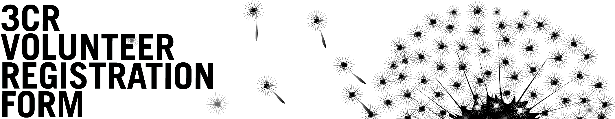

Date:

Name:

Address:

Phone Numbers: Email:

Are you a 3CR subscriber? Yes / No Subscriber No:

All volunteers at 3CR are required to be subscribers. You can subscribe on-line, in person or by ringing the station.

VOLUNTEERING AT 3CR
Why do you want to volunteer at 3CR? What programs do you listen to on the 3CR grid?

Do you have any experience working in a community organisation? If so, where and what did you do?

INTERESTED IN BECOMING A PROGRAMMER?
No radio experience is necessary to become a volunteer programmer at 3CR but you will need to have a good understanding about the programs on our grid.

What program/s are you interested in joining? Do you have any relevant experience or skills to contribute to this program?

Do you want to propose a new program? If so, briefly detail your ideas.

GENERAL VOLUNTEERING
3CR relies on volunteers to help run the station, volunteers are receptionists, members of the management committee and participate at every level in the running of the station.

Are you interested in reception and / or other general volunteer tasks? What days / times will you be available to volunteer?

Office use only

Contacted:

Meeting:

General notes:

General volunteer duties:

Current affairs: yes / no Referred to Current affairs:

New program: yes / no Existing program:

Referred to Program Co-ordinator:

Training date: Added to database:

